**User interface design and implementation**

1.When we created our own rental platform website, our first consideration was to investigate several transaction websites that are currently relatively popular in China. We need to learn and absorb the unique advantages of other websites. Ease of use is an important feature when users identify websites. We first designed an easy-to-observe logo for the site. 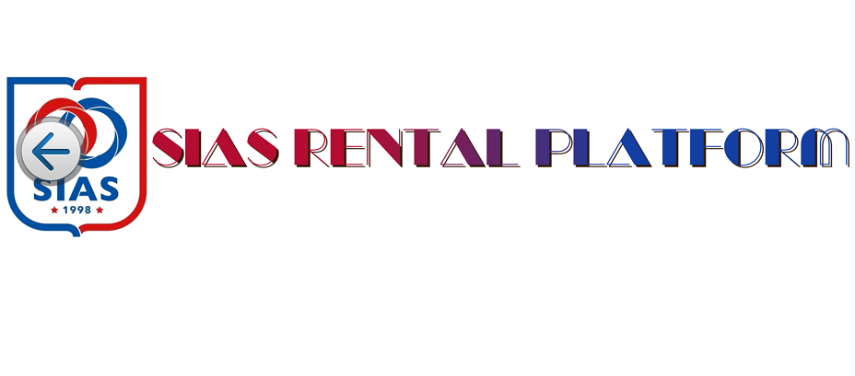

2.When we designed the logo, the first thing that came to mind was the need to create a search box that would allow users to easily search for things they wanted. The search box also makes recommendations based on your search history.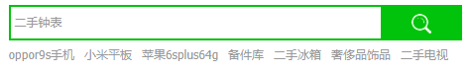

3.At the same time, we also consider that it is a disaster for users to search for the products they need in the disordered and disordered product pages. So we classified all the goods. In this way, users can easily search for what they need. 